

# PROJECT: Liberty Electronics GROUP NO: 02, BATCH: T1-1807-M0

USER GUIDE

1. When you open the index.html, you will see our logo at the top left of the page. When you scrolling down, you see some of the products included new product and hot sales. When you click on the product detail, you will have a word file about the detail of the product.

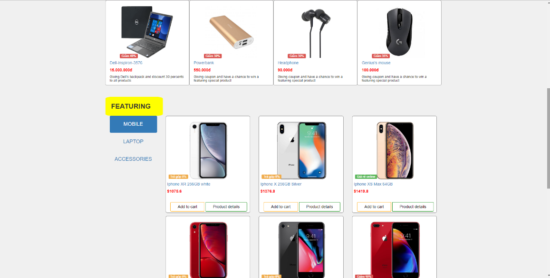

1. When you click on the Laptop, Mobile or Accessories, you will see every product of each items you need.



1. If you want to know about our company, click at the About Us and it shows you our information. Scroll down and you will see our company phone’s number.

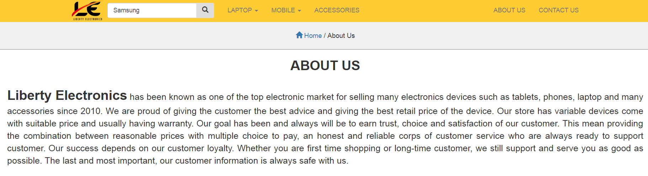

1. If you want to buy a product, add the product to the Add to Cart.

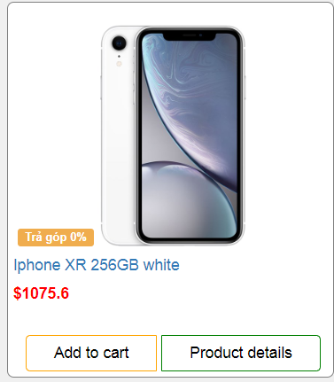

1. On the Technology News you will see the news about the new product.

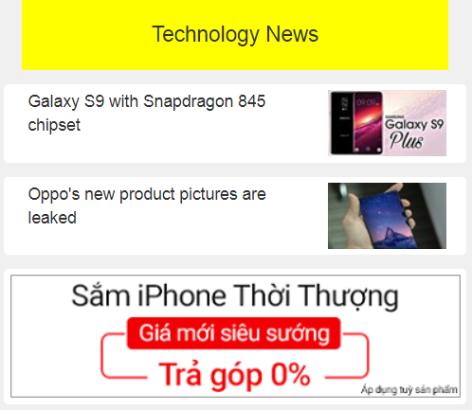

1. If you want to contact us, please call these numbers to get service

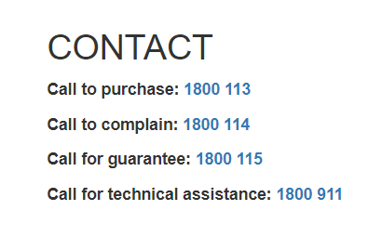

1. On the Featuring, there are our top sales products.

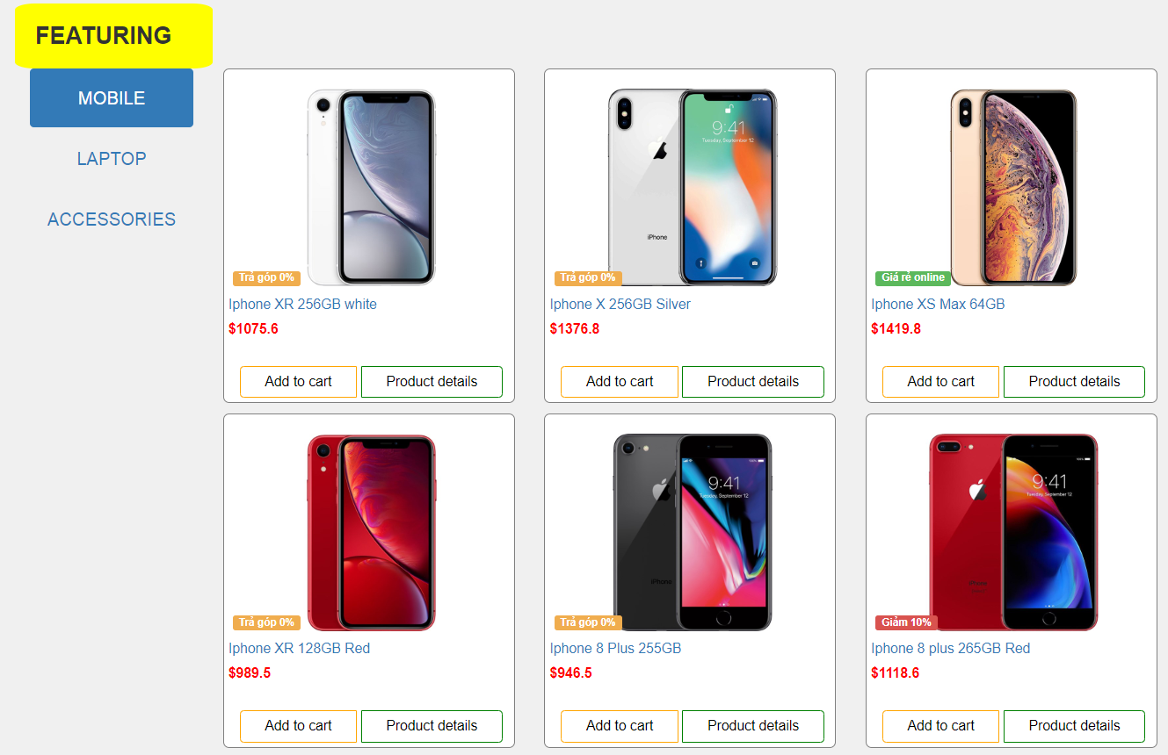

1. Our company’s address in case you want to buy directly

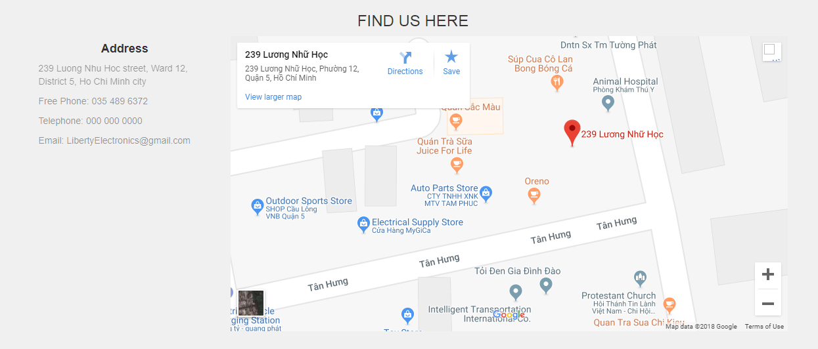

‘

1. The Quick View button is to give basic information of the product

